**NAME:** - ANSHUL SAINI  
**MAIL:** - [sainianshul7565@gmail.com](mailto:sainianshul7565@gmail.com)

**User ID**: - 34732

**Topic Assignment: -**

Application Packaging Process, End-to-End Application Packaging Process, Application Packaging benefits, App-V, Application Compatibility Toolkit (ACT), End-to-end Packaging Process, Windows 11 Benefits, Windows 10 Benefits, Considerations for an "App Pack", Difference between User, Admin, and System Context. in msi, How to assign a logon script to a profile for a local user, Logon Scripts to populate User Profile Data in msi application packaging

* **Application Packaging Process: -** Application packaging is the process of preparing software for deployment by bundling all necessary files, configurations, and dependencies into a single, standardized package.
* **End-to-End Application Packaging Process: -** The End-to-End Application Packaging Process is a structured workflow that ensures software applications are prepared for deployment. It includes identifying requirements, assessing packaging strategies, creating the package, testing it for functionality and compatibility, and finally deploying it to the production environment, ensuring smooth installation and operation across user systems.
* 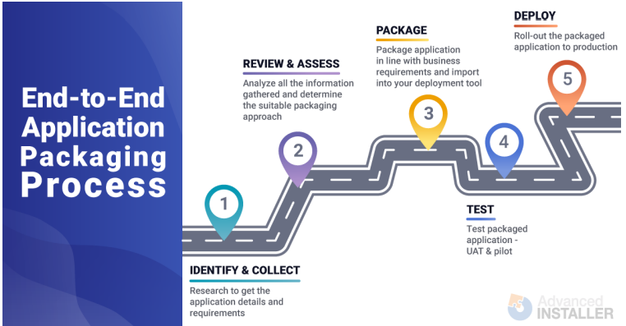**Practice Activity:** -
* **Application Packaging benefits: -** Application packaging ensures a consistent, stable, and reliable standard environment. It streamlines software deployment with necessary customizations, enhancing management efficiency. This process mitigates security issues, reduces the risk of business disruption, and lowers ongoing administration and support costs, making software maintenance more efficient and cost-effective for organizations.
* **App-V: -** App-V was first launched in 2006. It is an application Virtualization client that makes an application available to end users without installing it on a personal computer (PC). App-V, which enables applications to run in their own container on the client computer.
* **Application Compatibility Toolkit (ACT): -** This tool is developed by Microsoft Office that fix application compatibility issues occur during changes b/w Windows Operating System versions.
* **End-to-end Packaging Process: -** The end-to-end packaging process consists of 3 main steps

1. Application Discovery- Validate the source files and get all application requirements.
2. Application Packaging- Create the package based on discovery data.
3. UAT (User Acceptance Testing)- Ensure packaged application behaves like the original. Conduct testing in a virtual environment replicating production.

* 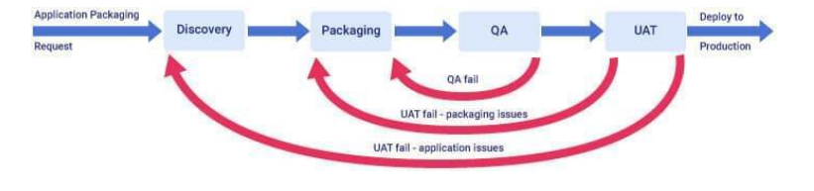**Practice Activity:** -
* **Windows 11 Benefits: -** Window 11 is extended version of Window 10. Windows 11 offers a simple and customizable interface, faster performance even on low-end devices, and Android app integration. Its clean design enhances usability, while regular updates ensure the latest features and security. Personalizing the taskbar and enjoying smoother multitasking are key advantages of upgrading to Windows 11.
* **Windows 10 Benefits: -** Windows 10 remains a solid choice for Legacy systems Familiar interface needs Budget constraints.
* **"App Pack”: -** An App Pack (Application Pack) is a collection of software applications that are packaged together for easy and consistent deployment to multiple computers. When creating or choosing an "App Pack," you must check if the apps work well on Windows 10 and 11, ensure they run smoothly, and don't slow down the system. Also, consider security needs and whether the new features in Windows 11, like Snap Layouts, will help users be productive.
* **Difference between User, Admin, and System Context: -** In a computing context, User, Admin, and System contexts define different levels of access and permissions. User context applies to standard users with limited permissions, while Admin context grants elevated privileges for system management tasks. System context, the highest level, often provides access to the core operating system and its resources, sometimes even bypassing user-level security restrictions.
* **Difference between MSIX and App V: -** MSIX and App-V are Microsoft tools used to package and run apps. App-V runs apps in a virtual environment without installing them fully, which helps avoid system issues. MSIX is the newer format that combines features of MSI, AppX, and App-V. It is more secure, easy to use, and works well with Windows 10 and 11 without needing extra setup.
* **MSI Packaging: -** MSI packaging is commonly used to install software on Microsoft Windows. It helps make software installation easy and consistent. This topic gives a simple explanation of what MSI packaging is, where it came from, and the different ways to create MSI packages for installing applications on Windows computers.
* **Logon Scripts to populate User Profile Data in msi application packaging: -** Logon scripts, combined with Active Setup, help configure user-specific data during login. Active Setup triggers actions like copying files or updating settings into the user profile. These scripts, written in batch or PowerShell, can be assigned via Group Policy. They're useful for setting up user environments post-installation. Best practices include proper error handling, security, testing, and clear documentation to ensure reliable deployment and support.